Semester | B.E. Semester VII – Computer Engineering
Subject | Scalable ML & BDA Lab
Subject In-charge | Prof. Shweta Jaiswar

Student Name
Roll Number
Grade and Subject
Teacher’s Signature

Experiment Number | 01
Experiment Title
Resources / Apparatus Required | Hardware: | Software:
Description
Program & Output | 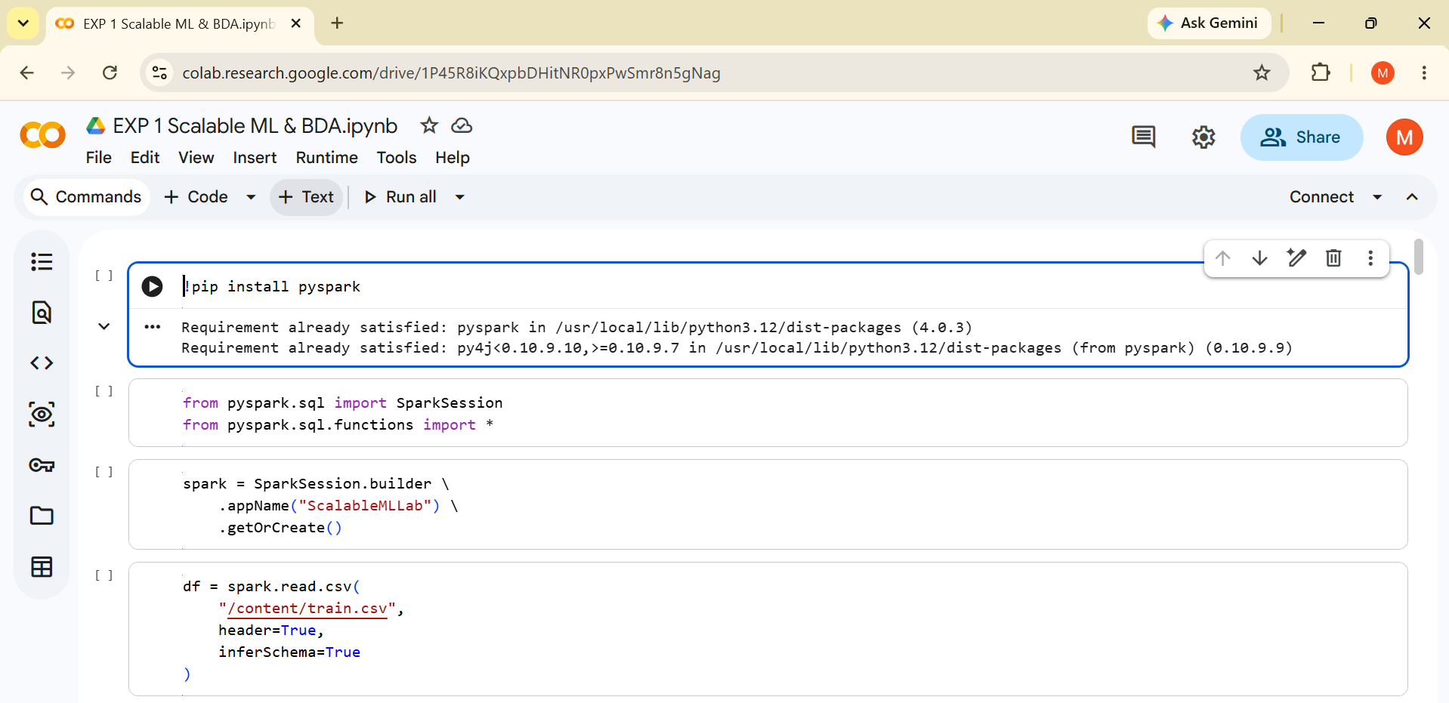
Conclusion:

